NAKTO ELECTRIC BICYCLE

LCD display Control Panel Instruction
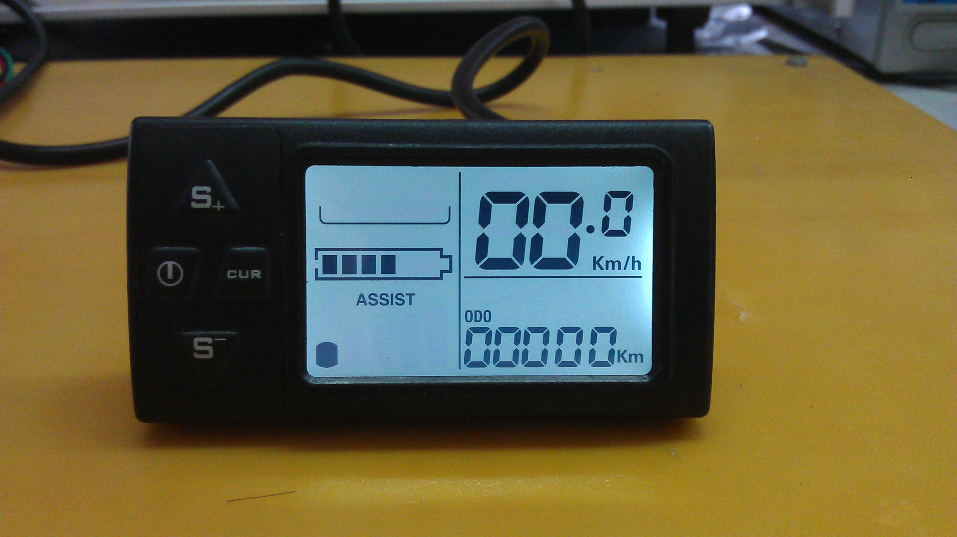

Model No：861-A
Working Voltage：DC24V or 36V（default） or 48V

wiring：
- Red（D+）: hot
- Black（GND）：Neutral
- Blue（DS）：switch for controller
- Yellow（DD+）：positive wire for light
- Green（RX）:Communication receiving
- White（TX）：Communication sending
- expandable：PWM PAS level controlling by Voltage ,separate speed sensor

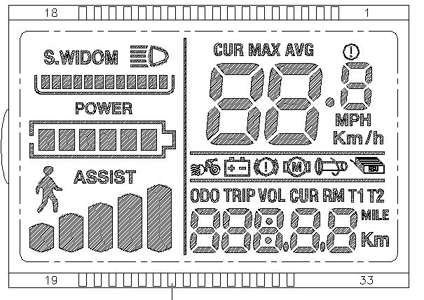

Introduction for display marks:
1. Head Light
2. Currency Level Status 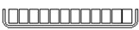(need support with certain model controlers)
3. Voltage Level Status 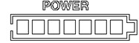
4. Multi-functional display Area 
Total Trip “ODO”, Single Trip “TRIP”, Voltage “VOLT”, Currency “CURRENT”, Remaining Travelling distance（need support by battery protection software）, Remaining Travelling time “TIME”.
5. Digital Speed 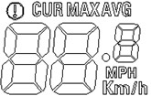
Current speed “CUR”, Maximum speed“MAX”，Average speed“AVG”
Unit： MPH, KM/H

6.Malfunction Display Area 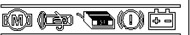
Motor 、Throttle、Controller、power switch brake、under Voltage protection
7．PAS level status display area 
PAS Level 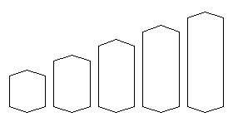（Level 0-5）、Cruise

Settings
P01：Background lightness : 1dark，2 normal, 3lightest；
P02：Distant unit，0：KM；1：MILE；
P03：Battery Voltage：24V，36V，48V，default 36V；
P04：Sleeping time：0，unlimited； 1-60 minutes；
P05：PAS Level: 0: 3 levels model :
Level1: 2V， Level 2: 3V， Level 3: 4V；
1,: 5 levels model:
Level 1:2V(12MPH), Level 2: 2.5V(13.1MPH)，Level 3: 3V15.7(MPH)， Level 4: 3.5V(16.3MPH)，Level 5:4V(19MPH);
P06: Wheel dismeter：Unit: inch；
P07: No of magnet steel for speed measurement： 1-100；
P08：Speed limit：Range 0-50 km/h，50 means no limit
P09：Setting for zero/none zero start: 0：zero start ；1：none zero start；
P10：Powering Model settings:
0 : PAS(throttle disabled, output power is corresponding to PAS levels)。
1 : Throttle(PAS disabled, output power is controlled by throttle turning, top speed it corresponding to PAS level settings)。
2 : PAS & Throttle(In P9, the setting has to be 1)。

P11：PAS sensitivity： Range 1-24；
P12：PAS starting intensity：Range 0-5；
P13：Magnet steel model for PAS: 5，8，12 three models
P14：Currency limit for controller : Range：1-20A , default 12A

Buttons:

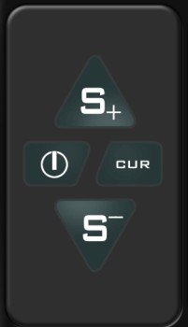
The buttons can be used with press or press and hold for 3 seconds for the function to be activated.

1.  Press to increase/decrease the PAS level to control the top speed
Press and hold both buttons to enter/exit to settings.
2.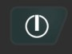 Press:change between models in multi-functional area display.
Press and hold to turn on and off LCD display
3. Press and hold this button to change the unit for speed.

4.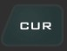 Press to turn on/off the Headlight.
Press and hold to enter 4 MPH cruise model while the E-bike is stand still. While the E-bike is running, press and hold to enter the cruise model in current speed.
Press and hold to exit cruise model while it is in cruise model.

Change Settings:

Press and hold both buttons to enter into settings: +

Press to switch between settings, press to increase the figures and to decrease the figures. Press to reserve the settings. While finish setting, just leave it for 10 sec, it will exit setting models.

